УДК 332.146

# Verbytska Anna

# Candidate of Sciences (public administration),

# Head of the Department of Marketing, PR-technologies and logistics

Chernihiv Polytechnic National University

**Babachenko Larysa**

# Candidate of Sciences (Economics),

# Docent of the Department of Marketing, PR-technologies and logistics

Chernihiv Polytechnic National University

# Вербицька А.В.

кандидат наук з державного управління,

завідувач кафедри маркетингу, PR-технологій та логістики

Національного університету «Чернігівська політехніка»

# Бабаченко Л.В.

# кандидат економічних наук,

доцент кафедри маркетингу, PR-технологій та логістики

Національного університету «Чернігівська політехніка»

**СOMMUNICATION STRATEGY DEVELOPMENT ALGORITHM FOR B2C STARTUPS**

**АЛГОРИТМ РОЗРОБКИ КОМУНІКАЦІЙНОЇ СТРАТЕГІЇ ДЛЯ В2С СТАРТАПІВ**

**АNNOTATION**

This article proposes an author's algorithm for developing a communication strategy for B2C startups, including: communication audit of B2C startup, setting goals and objectives of the communication strategy (business goals, marketing goals, communication goals); analysis of the business model of the startup (defining of the life cycle of the startup); defining of the target audience; development of communication messages for each segment in accordance with the profile; definition of startup communication tools; definition of communication channels of the startup; development of a communication plan; media plan development; evaluation of the effectiveness of the communication strategy. The proposed algorithm focuses on the in-depth analysis of the profile of the consumer's personality, which allows to predict behavioural responses in conditions of uncertainty and create an effective communication strategy B2C startup.

**Keywords:** startup communication strategy; startup business model analysis; startup life cycle; target audience; communication channels; media plan.

**АНОТАЦІЯ**

Ефективність та дієвість сучасної економіки значною мірою залежить від здатності швидко виводити на ринок інноваційну продукцію. Щоб прискорити час виходу такої продукції на ринок, збільшити її споживчу вартість, а також належним чином підготувати цільову аудиторію, необхідно розробити реалістичні маркетингові стратегії та плани, спробувати підвищити ефективність маркетингових операцій та впровадити найсучасніші маркетингові інструменти, які зараз все більше базуються на комунікаційних технологіях. Для безперервного зростання ефективності інноваційних продуктів на ринку в мережевій економіці необхідні нові методи та технології для управління інструментами просування маркетингу. Такі методи повинні враховувати інтереси різних груп споживачів. Цифрова трансформація бізнесу та зростання кількості B2C стартапів вплинули на необхідність створення ефективних маркетингових комунікацій із споживачами цифрових послуг та продуктів у висококонкурентному середовищі. Основними типовими проблемами, які досліджуються в рамках специфіки стартап-маркетингу, є проблеми витрат на просування, розробка маркетингової стратегії, яка найчастіше є інтуїтивно зрозумілою, а також проблеми спілкування з потенційними клієнтами. Стартапи зазвичай стикаються з конкретними проблемами, розвиваючи свою комунікаційну політику, особливо на ранній стадії. У статті пропонується алгоритм розробки комунікаційної стратегії для B2C стартапів, що включає: аудит комунікації B2C стартапу, визначення цілей та завдань комунікаційної стратегії (бізнес-цілі, маркетингові цілі, цілі комунікації); аналіз бізнес-моделі стартапу (визначення життєвого циклу стартапу); визначення цільової аудиторії (ведення розвитку клієнтів, створення CJM); розробка комунікаційних повідомлень для кожного сегменту; визначення інструментів комунікації стартапу; визначення комунікаційних каналів; розробку комунікаційного плану; розробку медіа-плану; оцінку ефективності комунікаційної стратегії. Запропонований алгоритм зосереджений на поглибленому аналізі особистості споживача, що дозволяє передбачити поведінкові реакції в умовах невизначеності та створити ефективну комунікаційну стратегію для B2C стартапу.

**Ключові слова**: комунікаційна стратегія стартапу; аналіз бізнес моделі стартапу; аналіз життєвого циклу стартапу; визначення цільової аудиторії; канали комунікації; медіаплан.

**АННОТАЦИЯ**

В статье предложен алгоритм разработки коммуникационной стратегии для B2C стартапов, включая: коммуникационный аудит B2C стартапа, постановку целей и задач коммуникационной стратегии (бизнес-цели, маркетинговые цели, коммуникационные цели) анализ бизнес-модели стартапа (определение жизненного цикла стартапа) определение целевой аудитории; разработку коммуникационных сообщений для каждого сегмента по профилю; определение инструментов коммуникации стартапа; определение каналов коммуникации стартапа; разработку коммуникационного плана; разработку медиаплана; оценку эффективности коммуникационной стратегии. Предложенный алгоритм сфокусирован на глубоком анализе профиля личности потребителя, который позволяет прогнозировать поведенческие реакции в условиях неопределенности и создавать эффективную коммуникационную стратегию B2C стартапа.

**Ключевые слова**: коммуникационная стратегия стартапа; анализ бизнес модели стартапа; анализ жизненного цикла стартапа; определение целевой аудитории; каналы коммуникации; медиаплан.

**Problem setting.** Despite modern challenges in the economic and social spheres, the field of innovative entrepreneurship is developing dynamically in Ukraine. Since 2015, the Ukrainian information technology market has doubled, and the growth rate is not slowing down. The startup ecosystem is quite multifaceted, but due to the uneven distribution of B2C and B2B startups and the infrastructure for them, the system is still developing. The most popular direction for launching startups is B2C. Most startups were launched in the e-commerce and B2B fintech. As the COVID19 crisis changed consumer habits and the way they buy the products, innovative entrepreneurs are increasingly opting for digital products for consumers.

The efficiency and effectiveness of the modern economy is highly dependent on the ability to quickly bring innovative products to the market. To accelerate the time for such products to enter the market, increase their consumer value, as well as properly prepare the target audience, it is necessary to develop realistic marketing strategies and plans, try to improve the efficiency of marketing operations and introduce the most modern marketing tools, which are now increasingly based on communication technologies. For the continuous growth of the effectiveness of innovative products on the market in a networked economy, new methods and technologies are needed to manage marketing promotion tools. Such methods should take into account the interests of different consumer groups.

**Recent research analysis.** Due to the lack of specialized research on startup marketing communications in in-depth analysis of the literature related to the study of the peculiarities of startup marketing and challenges for early-staged startups.

The resent research works show that there is an obvious difference in marketing communications of B2B and B2C companies [1]. Most of authors state that startups face the challenges in early stage communication [2-4].

Research by Rumler A. et al. considered the necessity of diversified communicative approach in order to lead the changes in startup potential customers or suppliers. They highlighted that many startups do not realize the value and power of communication as in the very early phase the startup product is not clear yet or may change [2].

Richter N. & Schildhauer T. studied the mechanisms of competitiveness of startups and innovative business in an ever-changing digital environment. The authors defined the methodological implications for business research, start-ups and policy making [3].

Lopez Garcia J. et al. defined the key factors that do not affect the optimization of conversions in B2C businesses such as the duration of the session and the rebound percentage, as well as the specific actions that must be carried out to attract and retain users in B2C companies that use the digital marketing ecosystem [5].

# Selection of previously unsolved parts of the problem. The need for in-depth study of consumer behaviour to quickly scale and attract new customers is especially relevant for the promotion of B2C startups. In this regard, there is a need to use a comprehensive communication strategy for promotion, which will be aimed at implementing the marketing strategy of the startup, through effective communication with the target audience.

# Formulation of the goals of the article (task statement). The research aim is to formulate the algorithm for developing a communication strategy for a B2C startup.

# The main research material. The main typical problems that are investigated within the framework of the specifics of startup marketing are problems of promotion costs, development of a marketing strategy, which is most often intuitive, as well as the problems of communication with potential customers.

# Startups are regularly facing specific challenges developing their communication policies especially in the earliest phase. At the same time, it is initially important to know startup communicative target groups and to adapt the communicative activities accordingly [1].

# The communication strategy development algorithm for B2C startups developed by the authors is presented on the fig.1.

# The algorithm consists of 10 stages:

# 1) *Communication audit of B2C startups.* Analysis of existing communications for startups should be carried out after the testing the MVP idea and with further growth, when there is a feedback from the end user [6]. Information could be obtained from the statistical data of the website, by the method of conducting a UX audit to assess the user's interaction with the site or application, conduct in-depth interviews, analyse the effectiveness of the channels and communication tools already involved [7].

# It is necessary to analyse the information field, where the tone of the mentions allows to understand what specific characteristics of a digital product or service consumers are discussing and what problems they face when interacting with a startup marketing communications. Since the information field of a startup is a collection of all mentions in the Internet, it is necessary to analyse all sites of mention: chats, forums, blogs, comments from bloggers, sites with reviews, etc. In order to collect data the special services could be used.

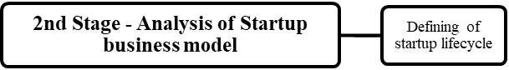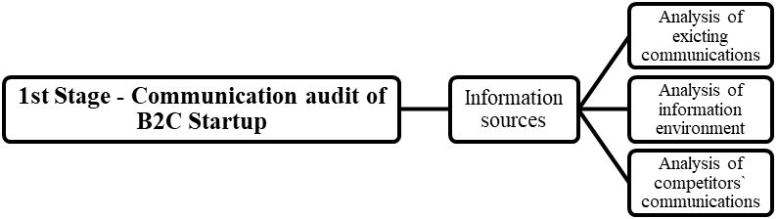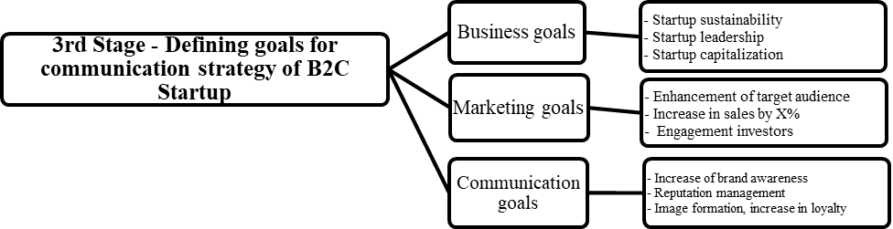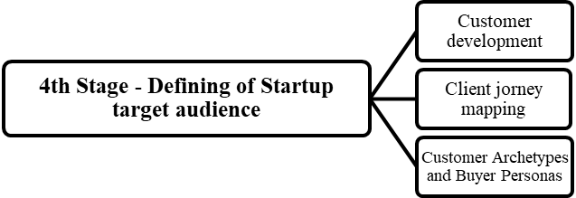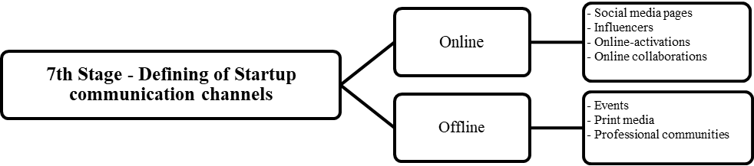

**Fig. 1 Сommunication strategy development algorithm for B2C startups**

# Analysis of competitors' communications, as a final step, will allow to evaluate their marketing promotion and create an integrated communication strategy.

# Despite the fact that a B2C start-up has an innovative idea that occupies a separate market niche and has no direct competitors, it is necessary to take into account indirect competitors that offer substitute goods. These may be regular firms, rather than startups, that serve the needs of the potential target audience of the startup. For the analysis, qualitative and quantitative studies of the target audience of competitors, their methods of engaging, compile CJM of an individual user could be conducted.

# 2) *Analysis of startup business model.* A business model is the way the startup uses to create value and generate profits. Value means uniqueness, which is the foundation of a competitive advantage.

# Defining the lifecycle of a startup allows determining what stage of growth a startup is in and developing an appropriate communication strategy. The classic startup lifecycle is tied to investment rounds. There are three early stages in a startup, where a startup is looking for the most effective business model: MVP (idea), Preseed stage, Seed stage. Next comes a period of active growth of a startup in stages: Round A (early growth), Round B (scaling), Round C + (expansion). At each round, the startup has the corresponding tasks:

# - Preseed: search for a buyer; then identifying the problem; solution proposal; first sales.

# - Seed: checking sales and communication channels; confirmation of the business model and market size.

# - Round A: scaling of sales and communication channels; test of hypotheses for expanding the target audience and scaling.

# - Round B: scaling in the local market; testing hypotheses for entering foreign markets.

# - Round C +: world market dominance [8].

# The startup is actively growing and has several development paths: it becomes a full-fledged business, buying out the shares of investors (LBO), goes to an IPO, or it is bought by a corporation (M&A) [9]. In accordance with the life cycles, it is necessary to define the purpose and objectives of the communication strategy.

# 3) *Setting goals and objectives of the communication strategy of a B2C startup.* At the beginning of the development it is necessary to understand what is the final goal and what tasks have to be performed in order to achieve it: business, marketing or communication. For startups as innovative projects within a limited budget an integrated goal but with an emphasis on increasing sales should be set.

# 4) *Defining of startup target audience*. The method Customer Development is used mainly for analysing the target audience of startups Customer Development is a qualitative method of target audience research: testing an idea or MVP prototypes of a future product for demand using potential identified consumer segments. It is necessary to segment the target audience according to their interests and needs, but not on the basis of socio-demographic characteristics. It is conducted by the method interview, which is divided into two types - the solution of the problem and the image of the ideal product [7].

# 5) *Development of communication messages for each segment of the target audience in accordance with the profile*. Communication messages are short conclusions based on an understanding of the client's needs, which allow to influence the outlook for the sale of a product or service. Messages should contain a solution of the problem and a positive result after buying. Messages are divided into several types: functional messages are messages that express the usefulness and functionality of the product for the consumer. Emotional messages are messages that allow to elicit an emotional responses from consumerss. Social messages are messages that relate to the consumer's need to identify with the group.

# 6) *Communication plan*. The communication plan considers the tools and communication channels suitable for the specific segment, which were taken from the algorithm (fig. 1).

# 7) *Development of the media plan.* A communication plan is necessary for the general media plan, which reflects the process of implementing the communication strategy.

# 8) *Evaluating the effectiveness of a communication strategy.* There are two main factors that determine the effectiveness of communication: measurability and analytics. Measurability includes the volume of material, tone, reach, share among the other publications, impressions and the number of attracted target audience. Analytics studies the causal relationships between the volume of the material and the quality of its perception by the target audience. The most widespared metrics are: advertising publishing equivalent (AVE) estimate; cost per contact (CPC), total audience reach (Media Outreach).

**Conclusions.** Nowadays a huge number of unique startup initiatives have been launched in Ukraine, many of which have been successful, and some have even become unicorns. Ukraine is one of the world leaders in the number of people working in the field of IT, and shows an annual increase in the field of information technology.

The role of communication in start-up companies is crucial. Communication inks the start-up company to external resources. It creates two-way communication processes to the external environment to detect changes and gather information. Communication identifies, creates, and disseminates strategic information. It provides means to handle growth effectively.

Communication strategy is especially important for B2C startups, where the end user is the client. The algorithm for developing a communication strategy for B2C because allows to find scalable ways to attract the target audience.

# REFERENCES:

1. Reklaitis, K. & Pileliene, L.. (2019). Principle Differences between B2B and B2C Marketing Communication Processes. *Management of Organizations: Systematic Research*. Vol. 81. P. 73-86. DOI: 10.1515/mosr-2019-0005.

2. Rumler, A., Schmidt, L. & Zumdieck, A.. (2019). Challenges in early stage communication for startups - two Case Studies. *Praxis WISSEN Marketing*. Vol. 1. DOI: 10.15459/95451.36.

3. Richter, N., Jackson P., Schildhauer, T. (2018). Startup clinics: applied research and “first aid” for early stage startups. *Entrepreneurial Innovation and Leadership*. P. 29-40.

4. Halle, I. T., Beekhof, T., & Ruel, H. (2016). How do start-ups engage with stakeholders? *Let's talk society.* Euprera congress. Groningen.

5. López García, J.J., Lizcano, D., Ramos, C.M., Matos, N. (2019). Digital marketing actions that achieve a better attraction and loyalty of users: an analytical study. *Future Internet* . Vol. 1(6), 130. DOI: 10.3390/fi11060130

6. Ries, E. (2011). The lean startup: how constant innovation creates radically successful businesses. Portfolio Penguin. 336 p.

7. Levy, J. (2021). UX Strategy : product strategy techniques for devising innovative digital solutions. O'Reilly Media, Inc, USA. 332 p.

8. Blank, S. & Dorf, B. (2020). The startup owner's manual: the step-by-step guide for building a great company. Wiley. 608 p. ISBN: 978-1-119-69068-9

9. Alvarez, C. (2014). Lean customer development: building products your customers will buy. ISBN-13: 978-1449356354.